Image Pyramids

Image Pyramids are the multiscale representation of an image. Multiscale means the different s of the image. For example. Let the original image be 256 x 256, this is further reduced to 128 x 128, then 64 x 64, then 32 x 32, then 16 x 16 and so till it cannot be reduced. The smaller reduced images are placed on top of the previous larger image to form a stack of images like pyramids.

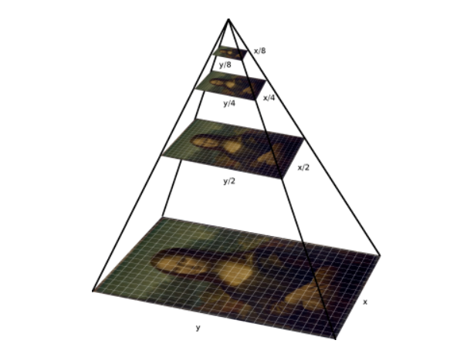

Utilizing an image pyramid allows us to **find objects in images at different scales** of an image. And when combined with a **sliding window** we can find objects in images in various locations. This method is used in HOG (Histogram Oriented Gradients), to better classify the object identification.

Working:

at each subsequent layer, the image is resized (subsampled) and optionally smoothed (usually via Gaussian blurring). The image is progressively subsampled until some stopping criterion is met, which is normally a minimum size has been reached and no further subsampling needs to take place. So, at each level to get the next octave (level), the column and row is divided in half, so the image is reduced to one – fourth in each level. So, going down the level, the image is reduced by 4 and going up the scale, the image is increased by 4. Gaussian blurring takes place, so these are known as the Gaussian Pyramid. Laplacian pyramid can be obtained, by subtracting a level in the Gaussian Pyramid, with its previous level. Doing so, will get the difference of both images, resulting in edges.

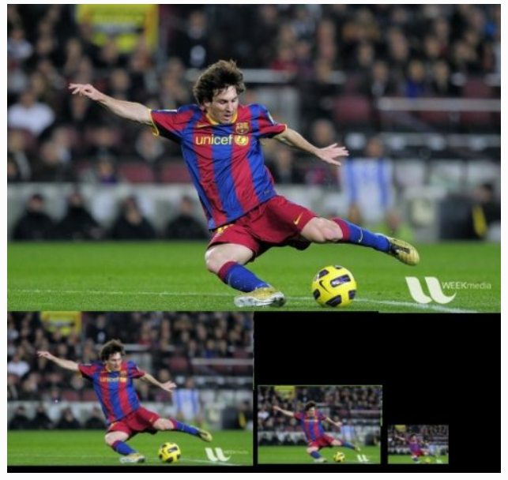 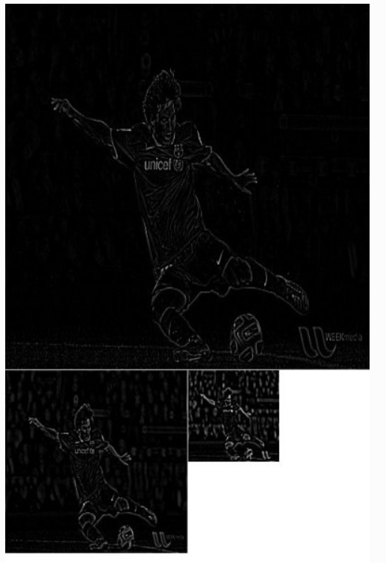

Gaussian Pyramid Laplacian Pyramid

Gaussian Image (G1) can also be got, adding the difference Pyramid (L1) (Laplacian), and the Gaussian Pyramid (G2). But, the G2 pyramid must first be scaled to the size of G1, this can be done by appending with zero or the rows and columns.

Gaussian Pyramid:

G1 -> G2 -> G3 -> ………. Gn

Laplacian Pyramid:

L1 -> G1 – G2,

i.e. Li -> Gi – G i+1